EXPENSE TRACKER APPLICATION USING JAVA

Name: Bandari Keerthi
Course: B.Tech CSE
Internship: Upskill Internship
Language: Core Java

Objective
The objective of this project is to develop a console-based Expense Tracker application using Java that helps users record, manage, and analyze their daily expenses efficiently.
Technologies Used
- Java (Core Java)
- File Handling
- Object-Oriented Programming (OOP)
- ArrayList
Project Description
The Expense Tracker is a console-based application that allows users to add, view, and analyze their expenses. The application stores data in a file so that information is not lost after closing the program. Users can also search expenses by category and view total expenses.
Features
- Add Expense with name, amount, category, and date
- View all expenses
- Calculate total expenses
- Search expenses by category
- Store data permanently using file handling
Output Screenshots
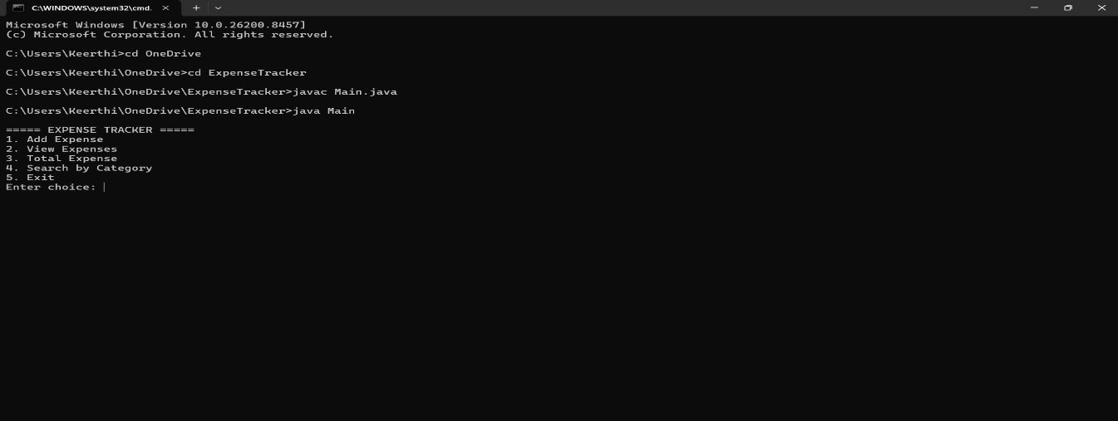
Main Menu
Add Expense

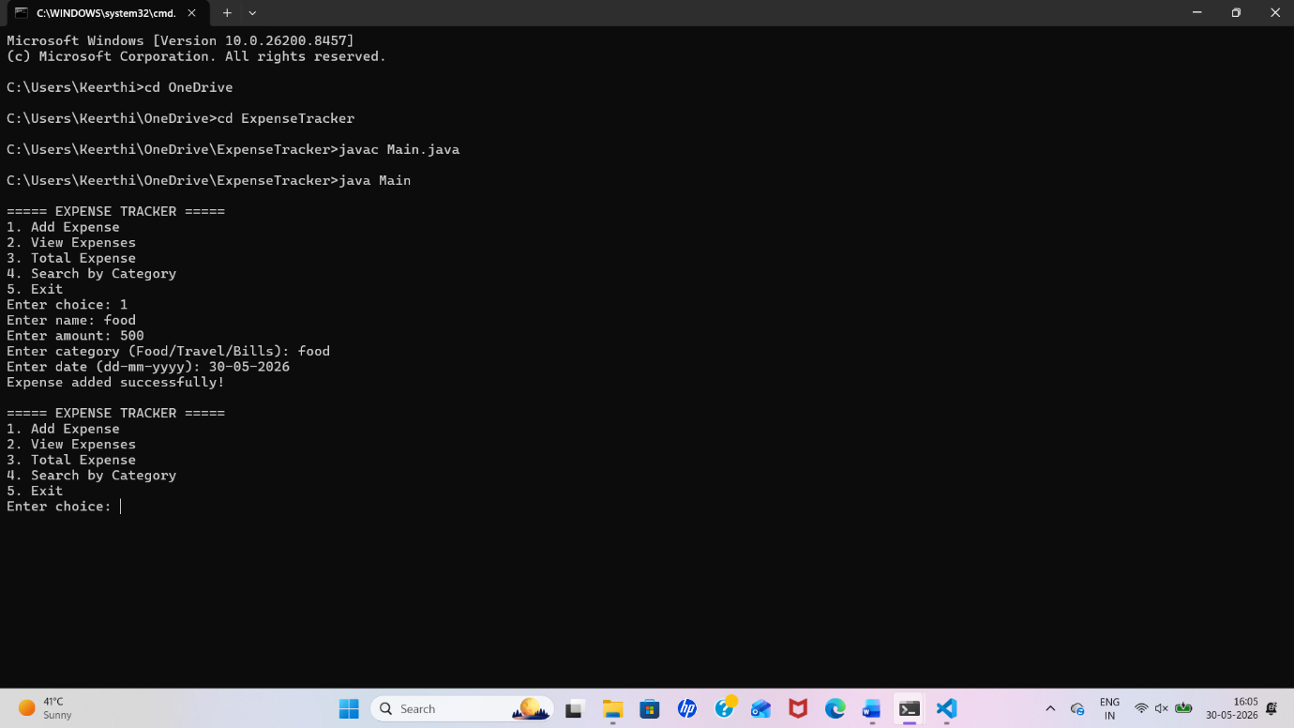

View Expenses
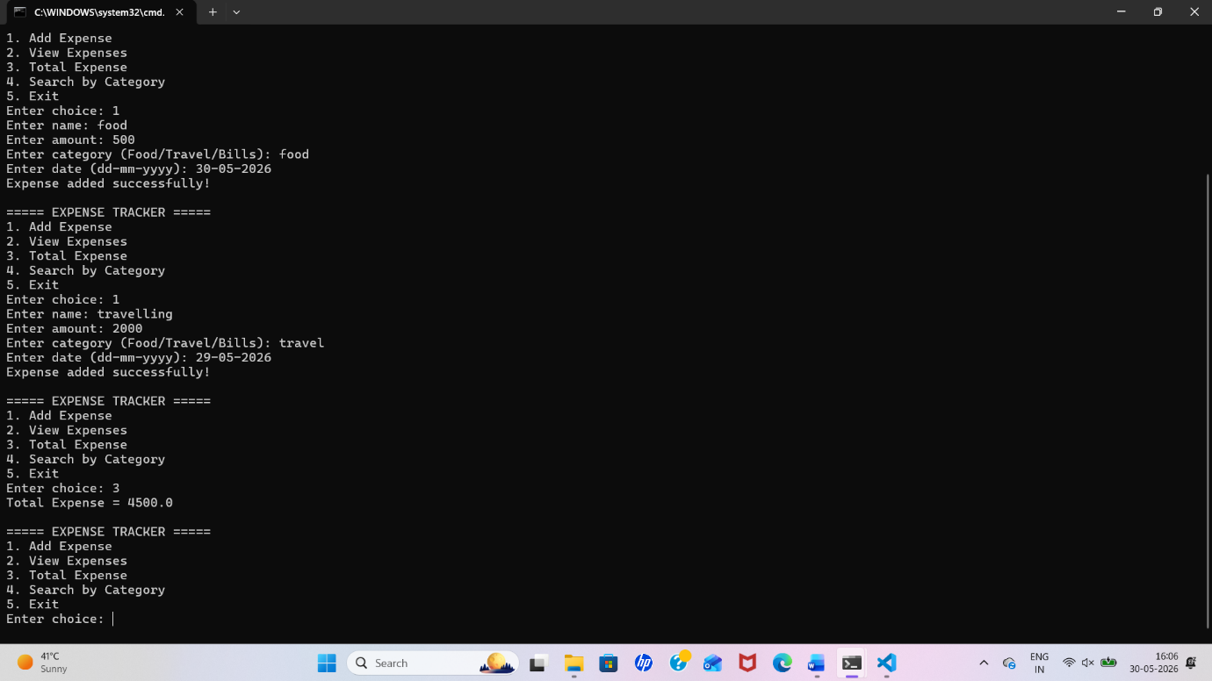

Total Expense
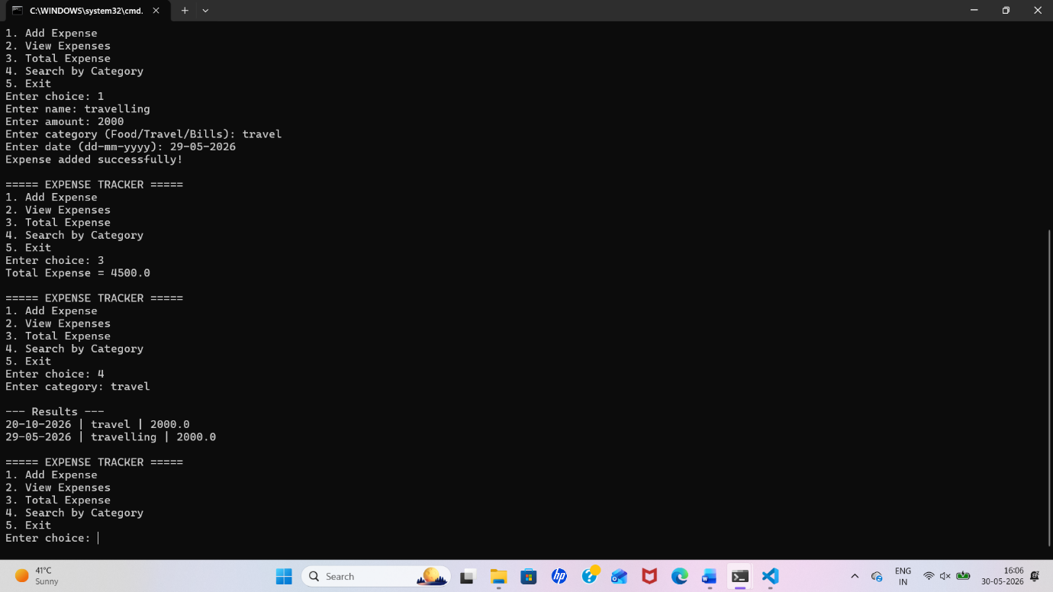

Search by Category
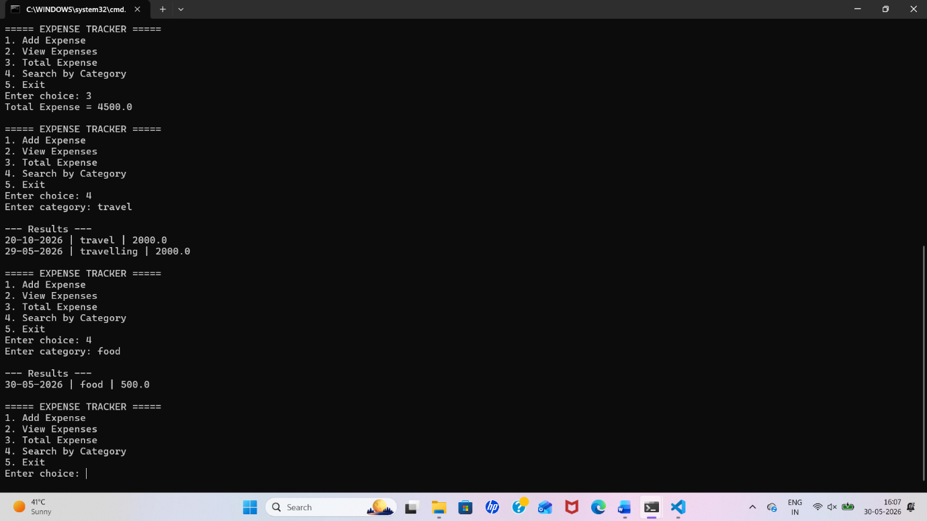

How to Run the Project
- Compile the program using: javac Main.java
- Run the program using: java Main
- Use menu options to perform operations
GitHub Link
https://github.com/keerthibandari167/ExpenseTracker
Conclusion
This project successfully demonstrates a simple Expense Tracker system using Java. It helps users manage expenses efficiently and provides a basic understanding of file handling and object-oriented programming concepts.

